Invoice Script

The Invoice script is a tool of communication between Travcom and Pastel. The building of this tool is predetermined by the format at which Pastel imports data. The tool has been customized for invoicing. The flow chart below shows how data flows and processed by the Invoice Script:

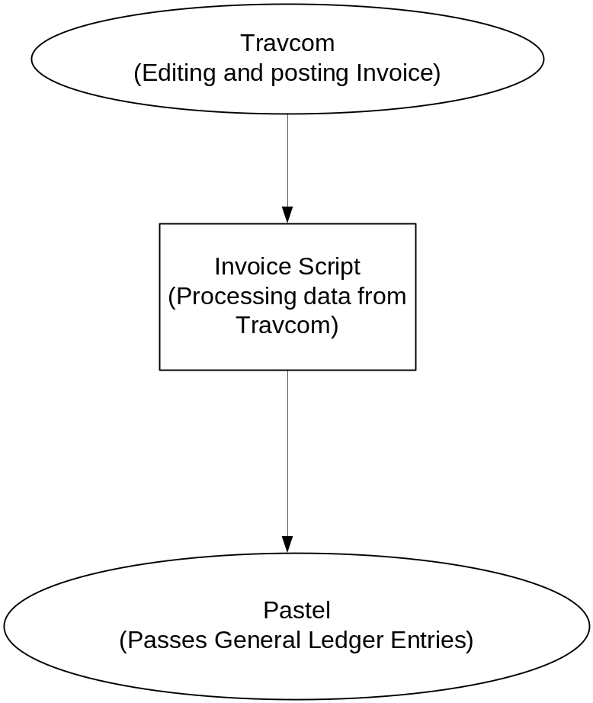

When an invoice is edited and posted in Travcom, the data is picked by the scripted and transforms it into a format recognizable by Pastel. After transforming the data, the processed data is then imported by Pastel from the script. This should be done on a daily basis.

